

Deder General Hospital Cough Clinic Protocol

July, 2016 EC
Deder, Ethiopia

1. Introduction
Respiratory illnesses remain among the leading causes of outpatient visits, emergency admissions, and inpatient mortality in Ethiopia. Common causes of cough include tuberculosis (TB), acute respiratory infections, COVID-19, asthma, and chronic obstructive pulmonary disease (COPD). The dual burden of communicable and non-communicable respiratory conditions has created an urgent need for structured, integrated, and patient-centered services.
At Deder General Hospital, the outpatient department (OPD), emergency unit, and inpatient wards routinely manage large numbers of patients presenting with cough. However, existing patient flow systems often mix coughing patients with the general patient population, thereby increasing the risk of transmission of airborne infections such as TB and COVID-19.
To address this challenge, the hospital has established a Cough Clinic and Cough Corner Protocol. This protocol provides a standardized approach for the early identification, triage, management, isolation, and referral of patients presenting with cough. It integrates infection prevention and control (IPC), efficient patient flow, and evidence-based clinical management.

2. Purpose and Scope
The purpose of this protocol is to provide comprehensive guidance for the establishment and operation of a cough clinic service at Deder General Hospital, including the integration of cough corners, pre-triage, triage, OPD, emergency, and isolation units.
This protocol applies to:
- All health workers in OPD, emergency, triage, and isolation wards.
- Patients presenting with cough of any duration.
- Ancillary staff responsible for patient flow and IPC.
- Hospital management responsible for resource allocation and oversight.
3. Objectives
3.1 General Objective
To improve early identification, safe management, and outcomes of patients presenting with cough while preventing nosocomial transmission of respiratory infections at Deder General Hospital.
3.2 Specific Objectives
- To establish a clear patient flow system for individuals with cough.
- To separate coughing patients from the general patient population at the earliest possible point of contact.
- To provide structured pre-triage and triage services for cough patients.
- To ensure rapid access to diagnostic and treatment services in OPD.
- To provide emergency stabilization and management for critically ill cough patients.
- To provide safe isolation facilities for suspected or confirmed infectious cases.
- To implement strict infection prevention and control measures.
- To integrate cough management services with TB, HIV, NCD, and COVID-19 programs.
- To strengthen documentation, HMIS reporting, and evidence generation.
- To promote community awareness and patient education on cough hygiene.

Flow
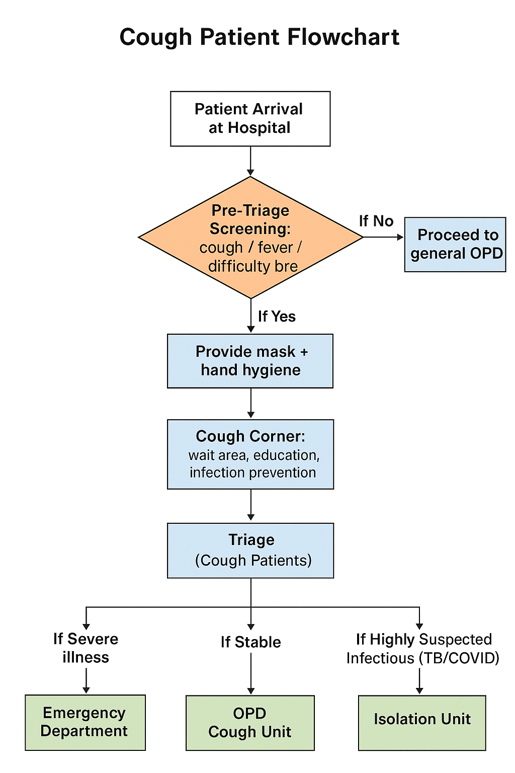
4. Guiding Principles
- Patient-centered care – patients should receive respectful, timely, and safe services.
- Equity and access – services should be accessible to all patients regardless of age, gender, socioeconomic status, or comorbidities.
- Infection prevention and control – separation, masking, ventilation, and hygiene are mandatory across all service points.
- Continuity of care – patients should be linked to follow-up clinics (TB, ART, NCD, or respiratory clinics).
- Efficiency and accountability – staff should follow standardized protocols and document actions.
- Integration with HMIS – data from cough services must feed into routine hospital reporting.
5. Service Delivery Structure
The Cough Clinic at Deder General Hospital is organized into the following service areas:
- Pre-Triage – first contact and screening for cough at the hospital entry.
- Cough Corner – waiting/seating area with infection prevention, masking, and patient education.
- Triage – structured clinical assessment to determine severity and priority.
- Outpatient Department (OPD) – diagnostic evaluation and management of stable patients.
- Emergency Department – stabilization and advanced care of critically ill patients.
- Isolation Unit – safe care for suspected or confirmed infectious cases (TB, COVID-19).
Each unit is interlinked to ensure smooth patient flow.
6. Pre-Triage Services
Definition:
Pre-triage is the initial screening step where patients are asked about respiratory symptoms before entering crowded waiting areas.
Activities:
- Greet and register all arriving patients.
- Ask standardized screening questions:
  - Do you have cough? If yes, for how long?
  - Do you have fever, night sweats, or weight loss?
  - Do you have shortness of breath or chest pain?
- Provide masks to coughing patients immediately.
- Direct coughing patients to the Cough Corner.
- Record patient details in a Pre-Triage Register.
Staffing:
- 1 nurse or health officer trained in screening.
Tools required:
- Pre-triage register.
- Masks and sanitizers.
- Educational posters.
7. Cough Corner
Definition:
A designated, well-ventilated area where coughing patients wait before full evaluation.
Location:
- Adjacent to pre-triage and close to OPD entrance, but separate from main waiting area.
Setup:
- Well-ventilated seating area (minimum 1 meter spacing).
- Posters on cough hygiene and mask use.
- Mask and sanitizer supply point.
- Dedicated waste bin with cover.
- Educational TV/radio (optional).
Flow:
- Patients wait here briefly until triage assessment.
- Staff check for worsening symptoms.
- Patients move to Triage in batches or individually.
Functions:
- Provide masks and enforce cough hygiene.
- Educate patients on cough etiquette.
- Register patients into the Cough Corner Register.
- Refer patients to Triage in a timely manner.
- Identify and immediately transfer critically ill patients to Emergency.
Recording Tool:
Date | Name of Patient | Age | Sex | Cough Duration (Days/Weeks) | Danger Signs (Y/N – specify) | Action Taken (e.g., Mask given, IPC advice, Sent to Triage) | Referral Unit (Triage/OPD/Emergency/Isolation) | Staff Initials

8. Triage for Cough Patients
Definition:
A structured clinical process to classify cough patients based on severity and urgency.
Steps:
- Record vitals (temperature, respiratory rate, SpO₂, heart rate).
- Identify red-flag symptoms: severe difficulty breathing, hemoptysis, altered mental status, hypoxemia.
- Classify patients:
  - Emergency/Urgent: send to Emergency.
  - Stable: direct to OPD.
  - Suspected TB/COVID: direct to Isolation.
Location:
- Directly linked to Cough Corner, but with a separate examination space.
Setup:
- Examination couch/bed.
- Desk and chairs for nurse/HO.
- Vital signs equipment: BP machine, thermometer, pulse oximeter.
- Oxygen supply available for emergencies.
Flow:
- Patients assessed by severity.
- Severe cases → Emergency.
- Stable cases → OPD.
- Suspected infectious cases → Isolation.
Staffing:
- 1 nurse or health officer per shift.
Tools:
- Triage register.
- Thermometers, pulse oximeters.
- Oxygen cylinders and resuscitation sets.
9. Outpatient Department (OPD) for Cough
Location:
- Within the OPD complex, with designated consultation rooms for cough patients.
Setup:
- Consultation desk and chair.
- Examination couch.
- Diagnostic sample collection area (sputum, swab).
- Linkage to laboratory and radiology.
Flow:
- Stable cough patients receive evaluation, diagnosis, and management here.
- Referral to TB clinic, ART clinic, or NCD clinic if needed.
Functions:
- Detailed history and physical examination.
- Diagnostic investigations: GeneXpert, sputum microscopy, CXR, CBC, RDTs.
- Clinical diagnosis and management.
- Referral to specialist clinics (TB, ART, asthma/COPD).
- Counseling on treatment adherence and cough hygiene.
Recording:
- Standard OPD register + Cough Clinic OPD register.
10. Emergency Services for Cough
Location:
- Inside the Emergency Department, with separate resuscitation space for respiratory patients.
Setup:
- Oxygen delivery systems (concentrators/cylinders).
- Nebulizers, suction machines.
- Emergency medicines (antibiotics, steroids, bronchodilators).
- Airway equipment (ambu bag, intubation set, ventilator if available).
Flow:
- Only critically ill patients are managed here.
- After stabilization → admitted to ward or isolation.
Target Patients:
- Acute severe asthma.
- COPD exacerbations.
- Severe pneumonia.
- Massive hemoptysis.
- Respiratory failure.
Services Provided:
- Oxygen therapy.
- Nebulization.
- Intravenous antibiotics and steroids.
- Airway management (intubation if needed).
- Rapid transfer to inpatient or isolation units.
11. Isolation Services
Location:
- A stand-alone unit or separate wing of the hospital.
- Must be physically separated from OPD and general wards.
Setup:
- Negative pressure rooms (if possible) or well-ventilated rooms with windows.
- Designated donning/doffing areas for PPE.
- Separate patient toilets and waste disposal.
- Zoning: clean area → buffer area → contaminated area.
Flow:
- Direct transfer from triage or emergency.
- Stay until diagnosis confirmed and safe referral arranged.
Indications:
- Suspected or confirmed TB.
- Suspected or confirmed COVID-19.
- Other droplet/airborne diseases.
Setup:
- Negative pressure rooms or well-ventilated areas.
- Zoning: clean zone, buffer zone, contaminated zone.
- Dedicated staff with PPE.
Patient Flow:
- Directly from triage or emergency.
- Managed until diagnosis confirmed and onward referral made.
12. Cross-Cutting Services
- Infection Prevention & Control: PPE use, environmental cleaning, ventilation, hand hygiene.
- Health Education: Posters, leaflets, counseling sessions.
- Nutrition Support: TB/HIV patients linked to nutrition unit.
- Psycho-social Support: Counseling for stigma reduction.

13. Staffing and Human Resources
- Pre-triage nurse
- Cough Corner staff
- Triage nurse/HO
- OPD clinician
- Emergency physician/nurse
- Isolation team
- Data clerk
- Cleaner & security staff
All staff trained in IPC and cough management protocols.

14. Infrastructure and Logistics
- Masks, gloves, sanitizers.
- Pulse oximeters, thermometers.
- Oxygen concentrators/cylinders.
- Nebulizers.
- GeneXpert machine, sputum containers.
- Ventilators for emergency.
- Educational materials.

15. Recording and Reporting
Registers required:
- Pre-triage register.
- Cough Corner register.
- Triage log.
- OPD log.
- Emergency log.
- Isolation register.
Monthly summaries submitted to HMIS focal person.

16. Monitoring and Evaluation
Indicators:
- Number of cough patients screened.
- % of patients provided with masks.
- % of cough patients triaged within 30 minutes.
- % of suspected TB cases tested.
- % of emergency cough cases stabilized.
- Outcome (admitted, discharged, referred).
Quarterly audits and supportive supervision recommended.

17. Challenges and Mitigation
- Stigma → patient counseling.
- Overcrowding → adequate space allocation.
- Resource shortages → advocacy to management.
- Staff workload → shift planning.

18. Linkages and Referral Systems
- TB DOTS Clinic.
- ART Clinic.
- NCD/Respiratory Clinics.
- Inpatient wards.
- Community health posts for follow-up.

19. Annexes
Annex 1: Pre-Triage Screening Checklist
Item | Yes/No | Remarks
Patient has cough (≥2 weeks)
Patient has cough <2 weeks
Fever present
Difficulty breathing / shortness of breath
Chest pain
Hemoptysis (coughing blood)
Weight loss / night sweats (suggestive of TB)
Contact history with TB/COVID patient
Oxygen saturation checked (if available)
Surgical mask provided
Hand hygiene done
Patient directed to Cough Corner

Annex 2: Cough Corner Register Template
Date | Name | Age | Sex | Cough Duration (days/weeks) | Danger Signs (Yes/No – specify) | Action Taken (mask, IPC advice, sent to triage) | Referral Unit (Triage/OPD/Emergency/Isolation) | Staff Initials

Annex 3: Cough Patient Flowchart
Text Version Flow:
- Patient Arrival at Hospital →
- Pre-Triage Screening: cough / fever / difficulty breathing?
  - If No → proceed to general OPD.
  - If Yes → provide mask + hand hygiene → send to Cough Corner.
- Cough Corner: wait area, education, infection prevention.
- Triage (Cough Patients):
  - If Severe illness → Emergency Department.
  - If Stable → OPD Cough Unit.
  - If Highly Suspected Infectious (TB/COVID) → Isolation Unit.
- Final Pathways:
  - OPD management.
  - Emergency stabilization.
  - Isolation diagnosis & referral.

Annex 4: Emergency Resuscitation Checklist
Item | Available (Yes/No) | Functional (Yes/No) | Remarks
Oxygen source (cylinder/concentrator)
Pulse oximeter
Nebulizer machine
Suction machine
Bag and mask (neonatal, pediatric, adult sizes)
Intubation set (ET tubes, laryngoscope, stylets)
Emergency drugs (adrenaline, salbutamol, steroids, antibiotics)
IV access equipment (cannula, fluids)
PPE (gloves, masks, gowns, goggles)

Annex 5: Staff Duty Roster Template
Date | Time | Staff Name | Role (Pre-Triage / Cough Corner / Triage / OPD / Emergency / Isolation) | Signature

Annex 6: Sample IEC (Information, Education & Communication) Materials
Posters / Messages to be displayed in Cough Corner and Waiting Areas:
- “Cover your cough and sneeze – use a tissue or your elbow.”
- “Always wear a mask if you are coughing.”
- “Wash hands or use sanitizer after coughing/sneezing.”
- “Seek medical care early if cough lasts more than 2 weeks.”
- “Keep distance of at least 1 meter from others if you have cough or fever.”
Leaflet Content Example:
- Causes of cough (TB, COVID-19, pneumonia, asthma, allergies, etc.).
- When to seek immediate care (danger signs).
- How to prevent spread (mask, hand hygiene, ventilation).
- Where to go in the hospital (Cough Corner → Triage → OPD/Isolation).

